**‘esp8266_data’ Table**

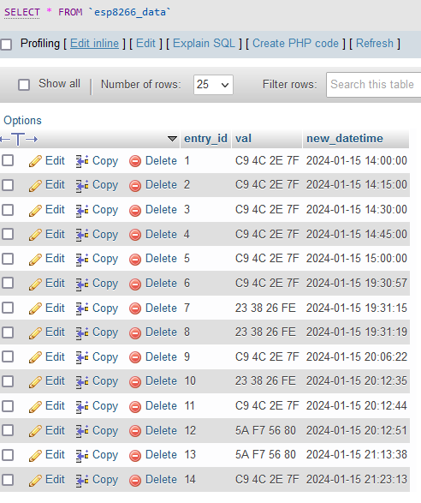

entry_id INT PRIMARY KEY,

val VARCHAR(100),

new_datetime TIMESTAMP DEFAULT CURRENT_TIMESTAMP

**‘tag_users’ Table**

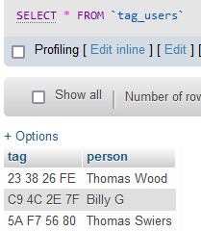

tag VARCHAR(100),

person VARCHAR(100)

**FINITIE NUMBER OF ROWS BECAUSE I ONLY HAVE 3 TAGS**